|  |
| --- |
| EPAM Systems, RD Dep. |
| MTN.BI.08 ETL and SQL Review |

|  |  |  |  |  |  |
| --- | --- | --- | --- | --- | --- |
| REVISION HISTORY | | | | | |
| Ver. | Description of Change | Author | Date | Approved | |
| Name | Effective Date |
| 1.0 | Initial status | Hanna_Hul | 19-NOV-2017 |  |  |

Contents

1. CREATE Storage Objects 3

2. Generate Test Data in Storage Layers 3

3. SQL*Plus 3

# CREATE Storage Objects

This task is already done.

# Generate Test Data in Storage Layers

Proceed with loading of Locations data into the normalized level.

Three users were created and appropriate tables. In the first step directory and external tables were created. External tables don’t contain any data, just references to data sources, that’s why it is important to create wrk_tables. This tables have the same structure as external tables, but they contains real data. Screens below show select from wrk_tables:

*select*from wrk_structure;*

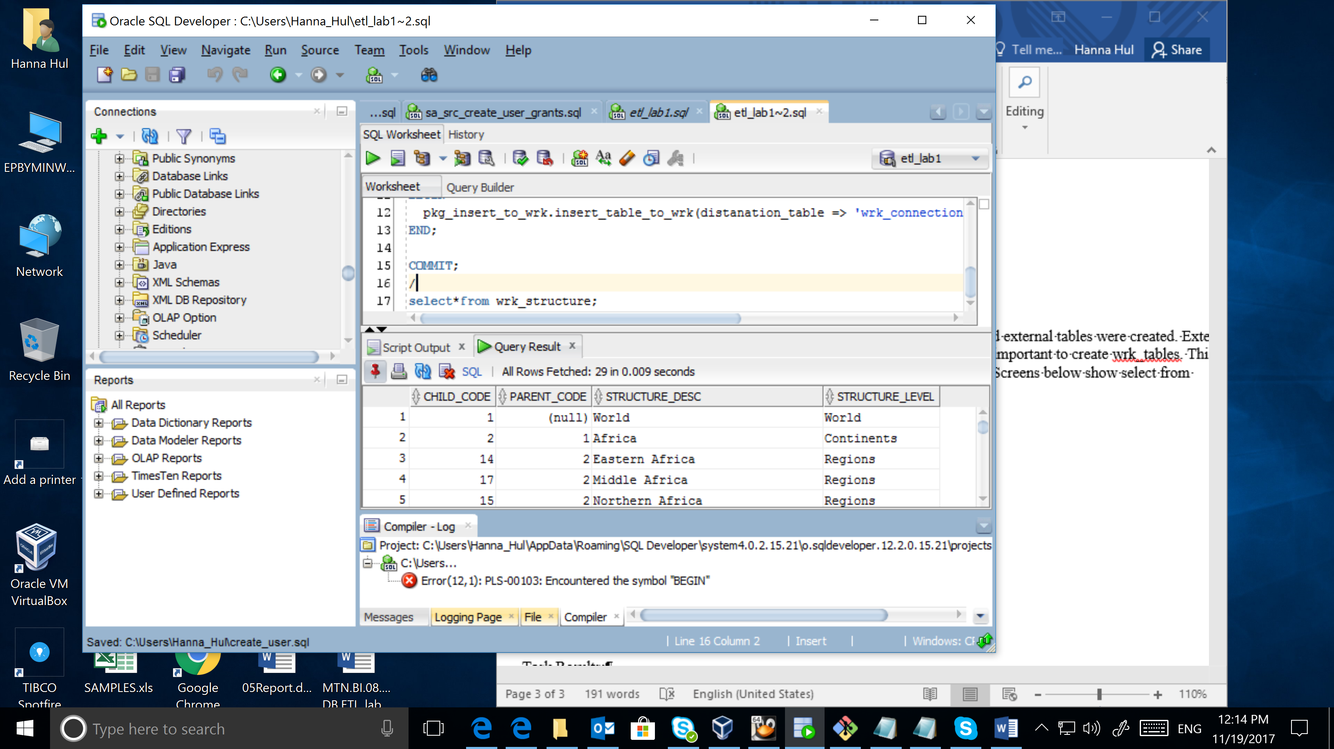

*select*from wrk_countries;*

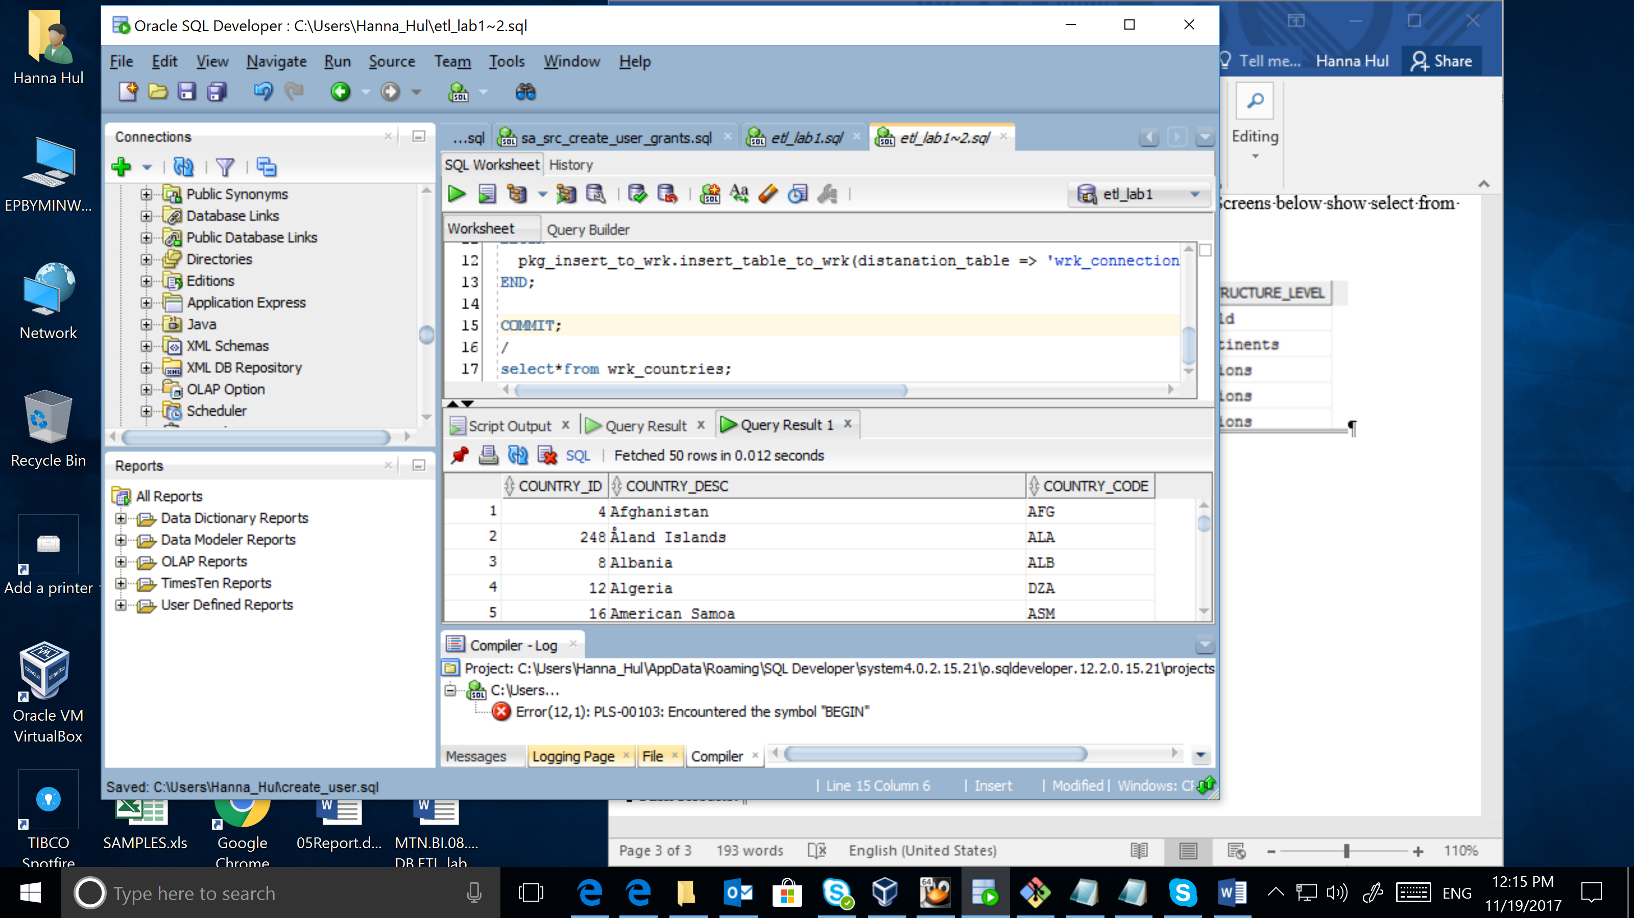

*select*from wrk_connection;*

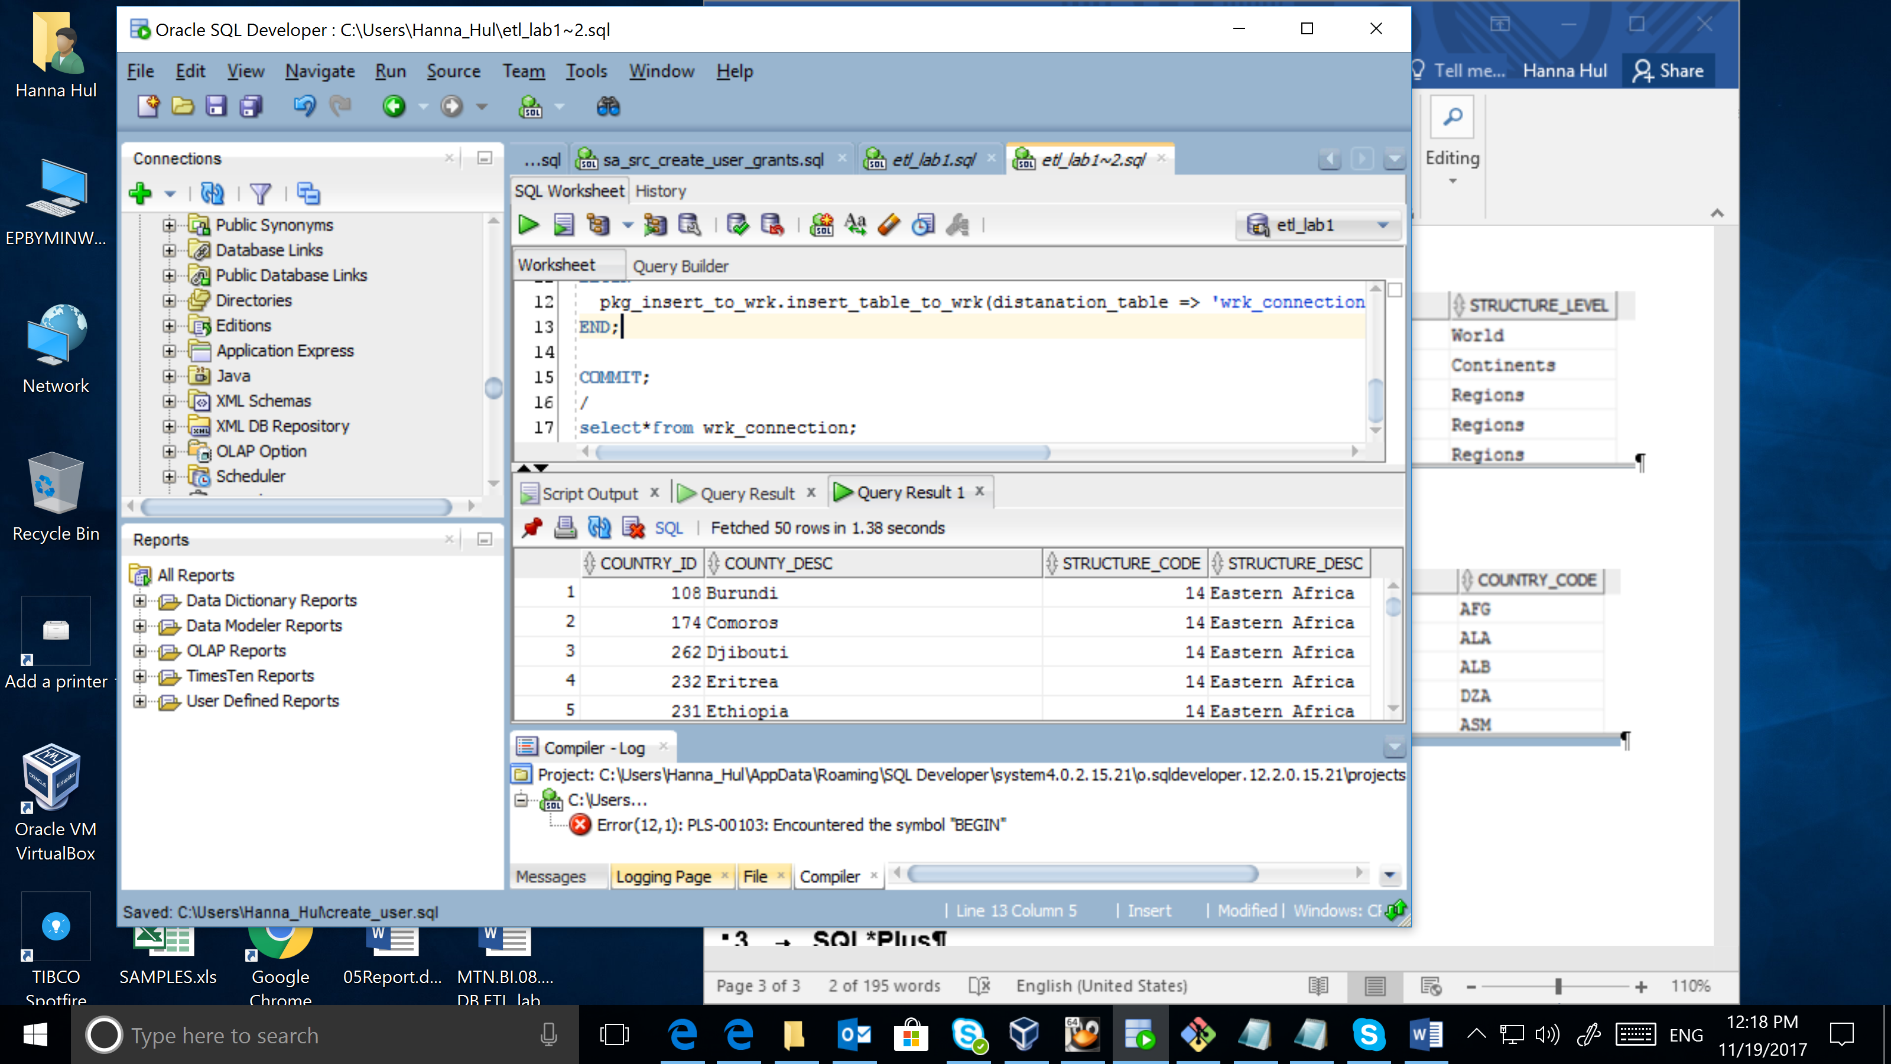

Then cleansing layer was created, where data should be restructured to the tables, which have the same structure as tables in 3nf layer.

select * from cls_regions;

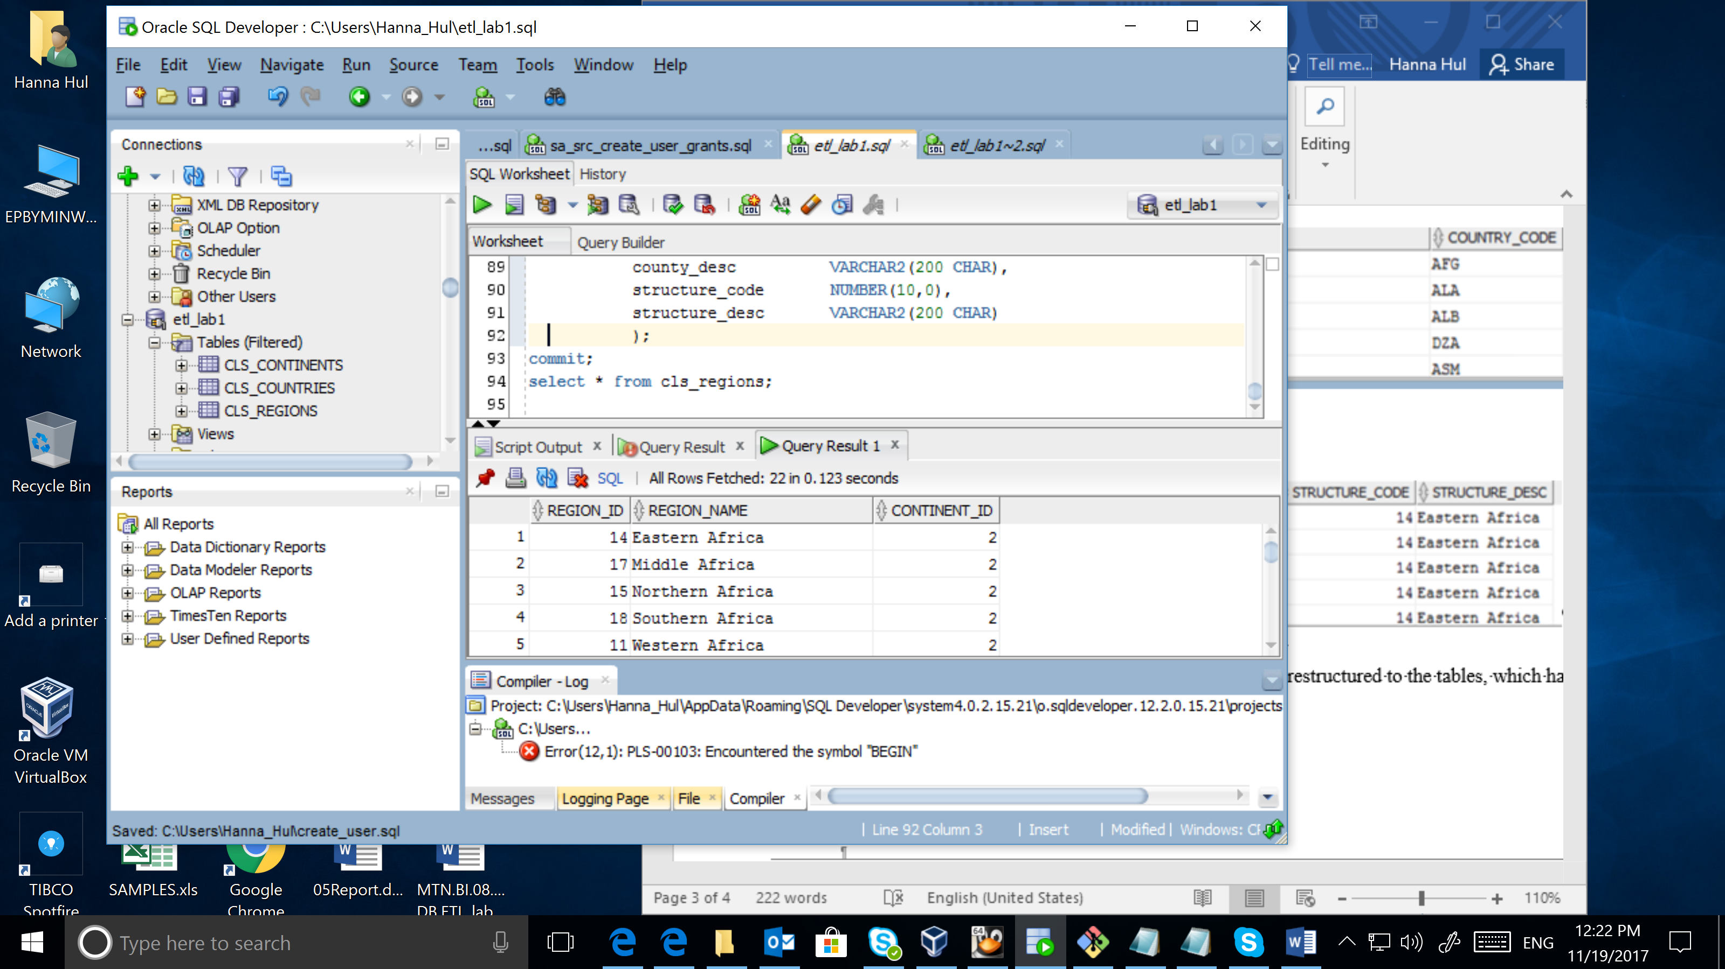

select * from cls_continents;

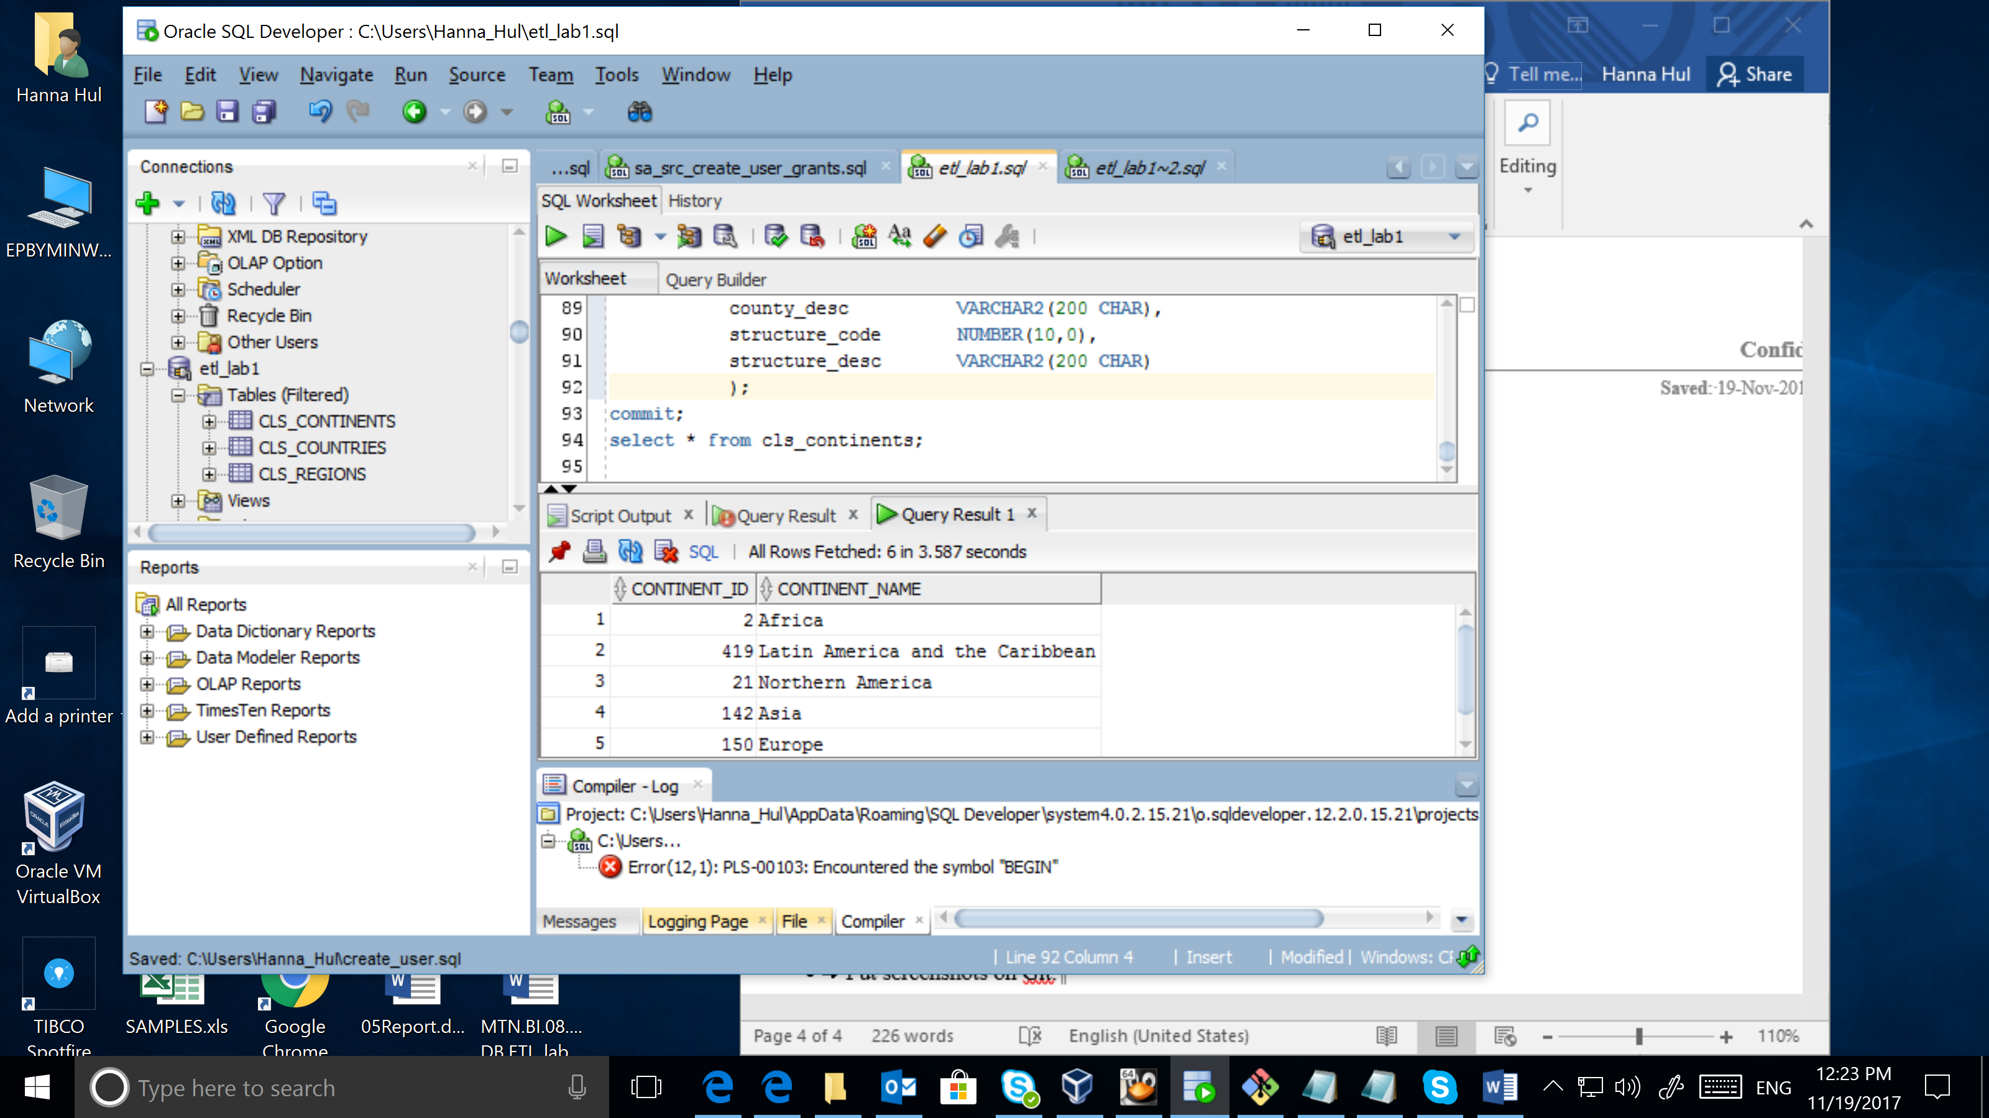

select * from cls_countries;

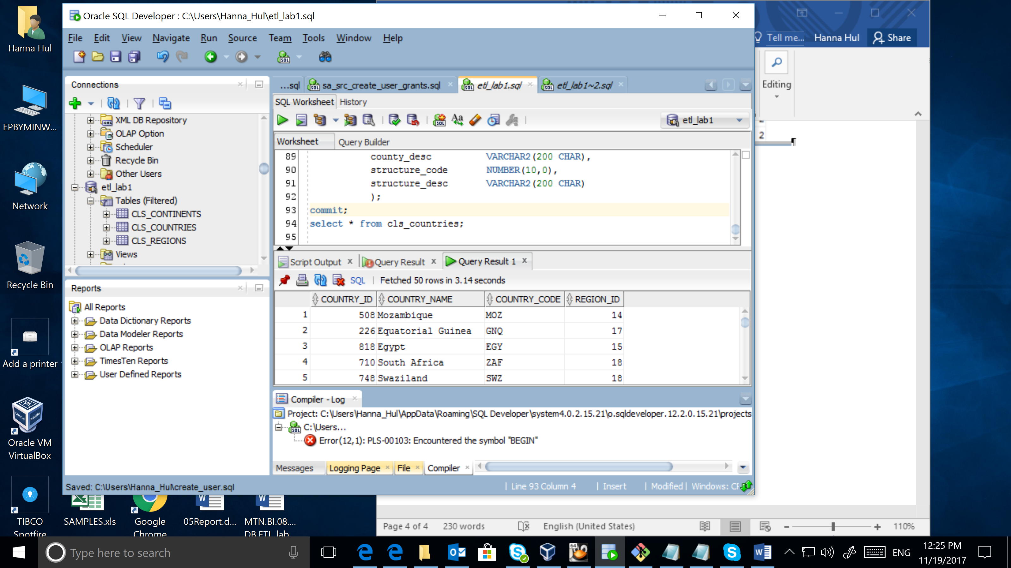

The 3nf layer and tables have the same structure as tables from cleansing layer, but tables have connection between each other.

# SQL*Plus

Connect to a database via SQL*Plus client and do next steps:

* 
 